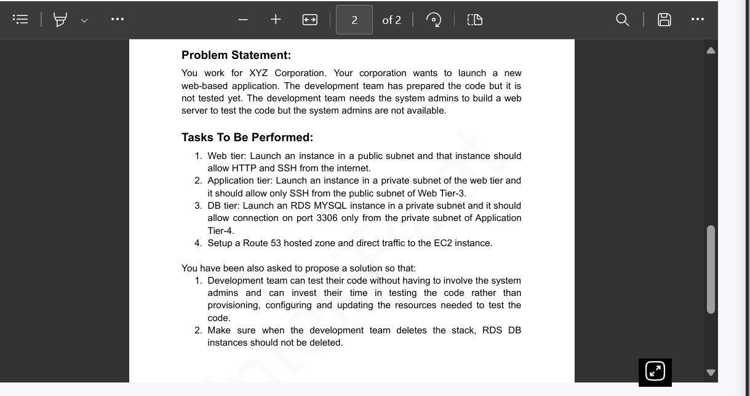

Solution

The solution to your problem can be achieved using AWS services like EC2, RDS, VPC, and Route 53. Also, AWS CloudFormation can be used to automate the provisioning and management of resources.

Steps to Follow

Web Tier

1. Launch an EC2 instance in a public subnet.
2. Configure the security group to allow HTTP (port 80) and SSH (port 22) from the internet.

Application Tier

1. Launch an EC2 instance in a private subnet.
2. Configure the security group to allow only SSH (port 22) from the public subnet of the Web Tier.

DB Tier

1. Launch an RDS MYSQL instance in a private subnet.
2. Configure the security group to allow connections on port 3306 only from the private subnet of the Application Tier.

Route 53

1. Create a hosted zone in Route 53.
2. Create a record set to direct traffic to the EC2 instance of the Web Tier.

AWS CloudFormation

To allow the development team to test their code without involving the system admins, you can use AWS CloudFormation. This service allows you to model and provision AWS and third-party application resources. You can create a CloudFormation template that describes all the AWS resources that you want (like Amazon EC2 instances or Amazon RDS DB instances), and AWS CloudFormation takes care of provisioning and configuring those resources for you.

Here is a sample CloudFormation template:

Resources:

MyEC2Instance:

Type: 'AWS::EC2::Instance'

Properties:

ImageId: ami-0abcdef1234567890

InstanceType: t2.micro

KeyName: my-key-pair

SubnetId: subnet-0123456789abcdef0

SecurityGroupIds:

- sg-0123456789abcdef0

RDS DB Instances

To make sure that RDS DB instances are not deleted when the development team deletes the stack, you can set the DeletionPolicy attribute to Retain for the DB instance in the CloudFormation template.

Resources:

MyDBInstance:

DeletionPolicy: Retain

Type: 'AWS::RDS::DBInstance'

Properties:

AllocatedStorage: '5'

DBInstanceClass: db.t2.small

Engine: mysql

MasterUsername: admin

MasterUserPassword: secretpassword

This way, the development team can focus on testing the code rather than provisioning, configuring, and updating the resources needed to test the code.